**Operating System mini project**

**(10 marks)**

✓ **Task 1**

Write a shell script that computes the gross salary of an employee according to the following.

1) if basic salary is <1500 then HRA 10% of the basic and DA =90% of the basic

2) if basic salary is >1500 then HRA 500 and DA =98% of the basic  
The basic salary is entered interactively through the key board.

echo "Enter the Basic Salary:"

read basic_salary

if [ $basic_salary -lt 1500 ]

then gross_salary=$((basic_salary+((basic_salary/100)*10)+(basic_salary/100)*90)) echo "The gross salary : $gross_salary"

fi

if [ $basic_salary -ge 1500 ]

then gross_salary=$(((basic_salary+500)+(basic_salary/100)*98))

echo "the gross salary : $gross_salary"

fi

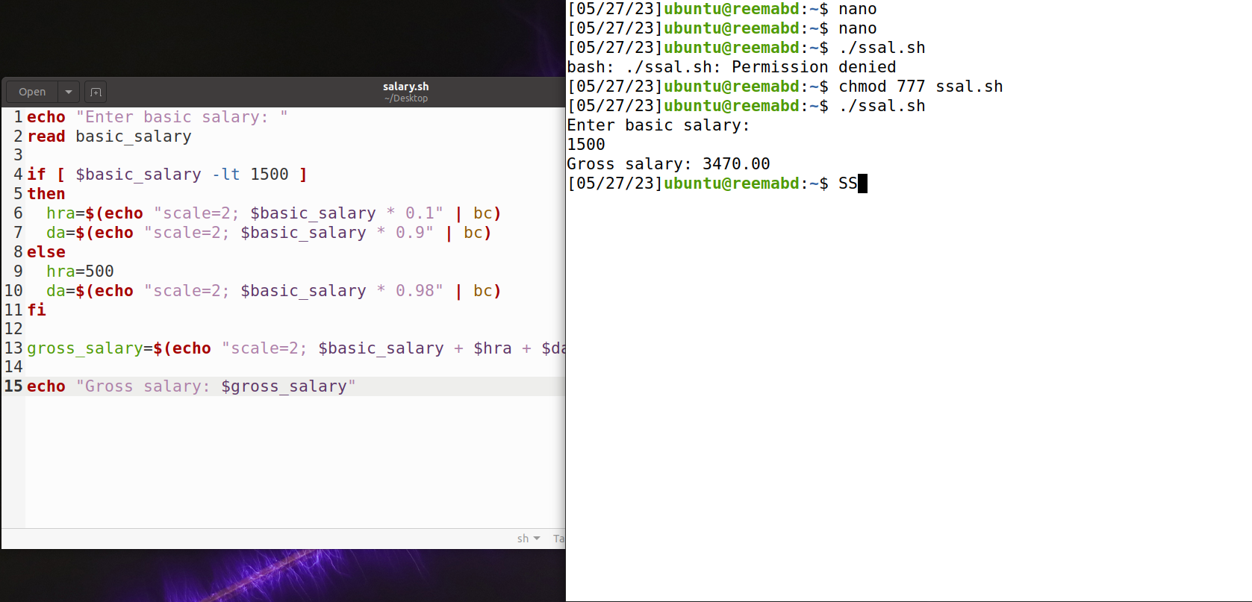

✓ **Task 2**Write a script to determine whether a year is leap or not.

echo -n "Enter year (YYYY): "

read y

a = 'expr $y%4'

b = 'expr $y%100'

c = 'expr $y%400'

if [$a -eq 0 -a $b -ne 0 -o $c -eq 0]

then

echo "$y is leap year"

else

echo "$y is not a leap year"

fi

